 | JJune 2022 | ARC Marion, Inc., was established in 1959, to create opportunities for persons with intellectual and developmental disabilities.  We offer a variety of services and supports including, Adult Day Training Programs, Life Skills Training, Supported Employment, Supported Living and Group Homes. Arc staff focus on helping each person be a part of their community, rather than apart from it, by creating opportunities for each of us to fill valued social roles and active lives in the communities where we live, work and play.
Meet our New CEO  The Arc Marion, Inc. Board of Directors concluded their months long search for the new CEO, get to know him on Page 2! | 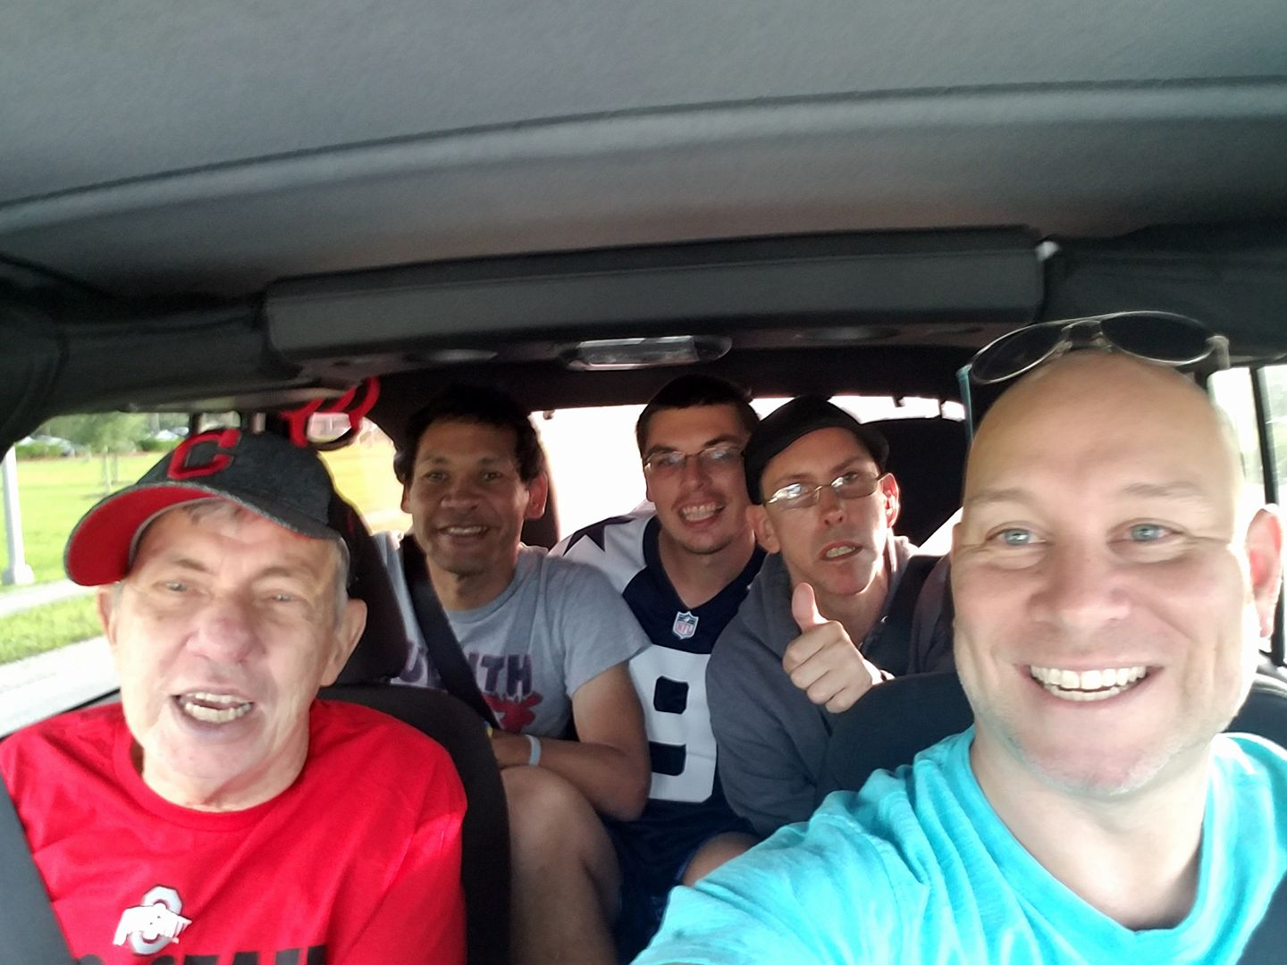  It’s Going to be a FUN ride!!!
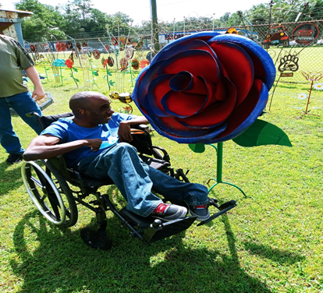 | ADT CHANGES  Exciting changes are here! Go to Page 3 to read all about the changes in our ADT
 |  | 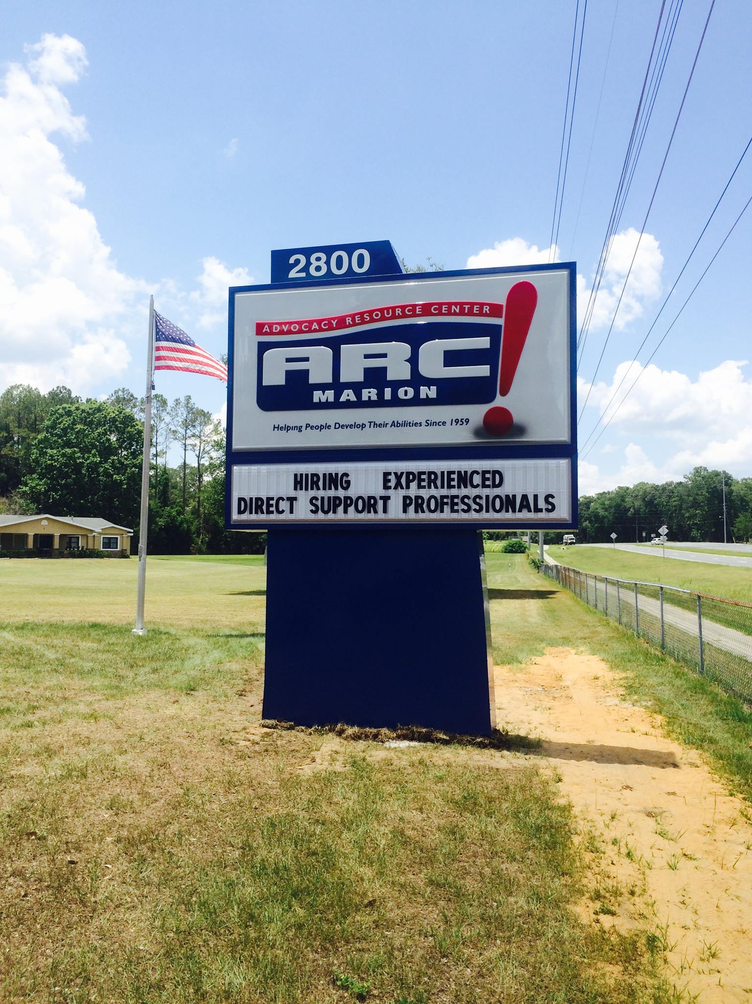
WHY WORK HERE?  Work with passion and get paid to do what you love!  FINISH READING ON PG.4 | 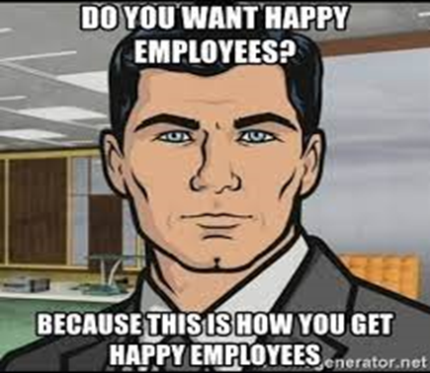
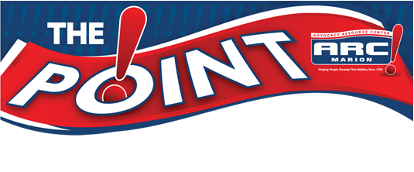
Friends, families, supporters…
We have some exciting news to share with you. After a rigorous application and interview process, the Arc Board of Directors unanimously agreed to appoint Sean McLaughlin as the new CEO of Arc Marion!
Sean’s experience with individuals who have intellectual and developmental disabilities came at an early age, as he grew up in a home with an aunt who had Down Syndrome. Much of his life’s work has revolved around him supporting and advocating for our most vulnerable citizens. Mr. McLaughlin owned a consulting firm, that assisted families with moving to Florida and navigating through the support systems, and setting up services. Sean also was the COO for a former Arc in southwest Florida. There, he focused on creating unique programs and expanding services and supports. From the start of Sean’s tenure, and throughout much of COVID, he was able to help significantly increase revenue, while bringing services to hundreds of new clients.
In searching for a new CEO, our desire was to find a person with strong leadership and organizational capabilities, a visionary who will take us forward into a new and rapidly changing world. More importantly, we wanted a leader who is committed to creating opportunities and demolishing barriers, so that people with disabilities in Marion County, can be seen, heard and valued. In Sean, we found that his passion is infectious, and, we believe that you will too.

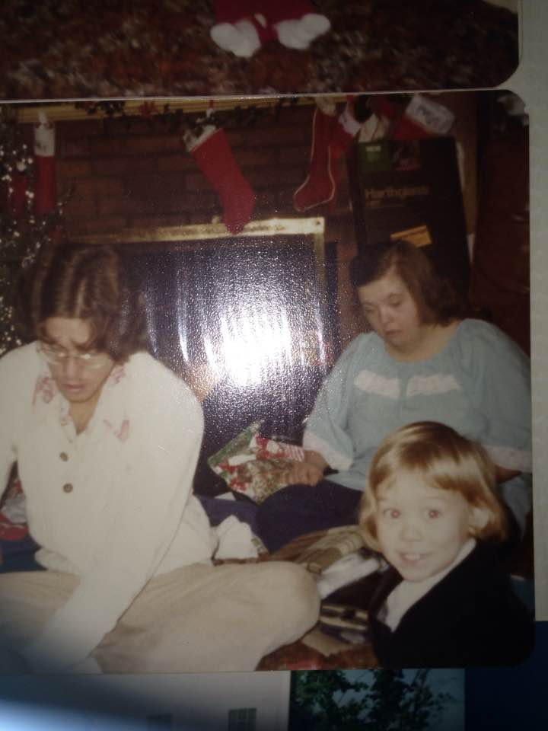
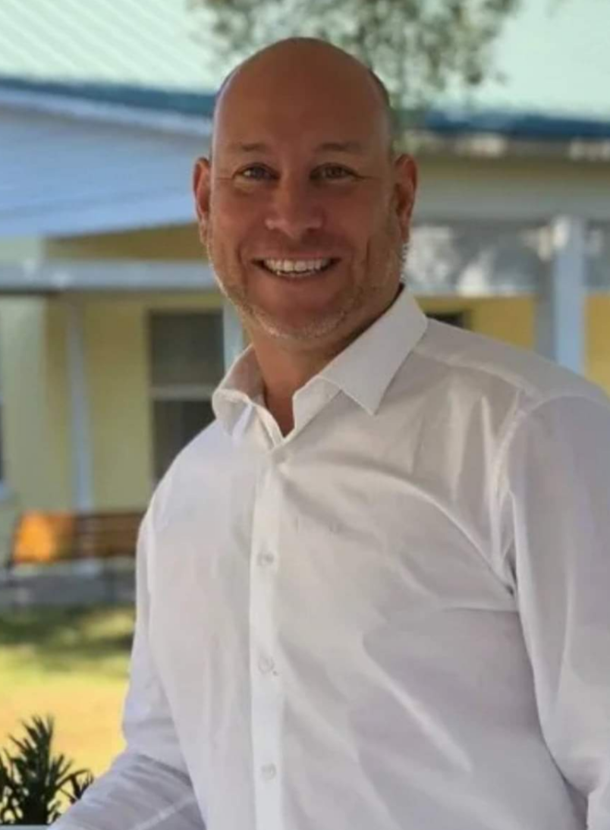

Exciting Changes in our Adult Day Training Program….
As far as our ADT, there are major changes underway. Contract, or piece-work, is no longer the focal point of the day program. There will now be a heavy focus on getting off campus and into the community, and utilizing the life skills we work on each day and seeing their real-life application.
Our ADT is going to fall under 4 umbrellas, and clients will have the opportunity to choose which one is best for them. We now have a Recreation based program for our senior and intensive care population. This “track” will focus around socialization, recreation, and physical movement. This is for clients who want to “retire” or don’t want to attend a “school” anymore, but they want the opportunity to get out of their houses and have fun and meaningful days. The next “track” will be our Independent Living program, for clients who are living outside of the family home, are planning on living outside of their family home, and/or are employed or want to be. This group will focus on employability skills, social skills, shopping, cooking, tech, etc. The next “track”, Education, is aimed towards the clients who aren’t ready for the IL program, nor fit the parameters for the Recreation Program. Here they will learn the skills to be as independent as possible and how to be productive and valued members of their community. The final track is our Contract Work. We understand that there are some consumers who value working, even if it means sub-minimum wage. As long as clients continue to request this, we will honor it.
Clients in all of the “tracks” will also be able to choose to spend time in any of our specialty programs, which include Theater, Art, Music, Job Training, Social Media (we are going to have our own tik-tok channel, a YouTube Channel, and true investigative journalists and reporters who will go into the community and tackle the problems that are most important to them!)
When a potential client comes to tour our ADT, they may find that certain “tracks” are full, they can choose to go into another program, or go on a waitlist for the “track” they truly desire.
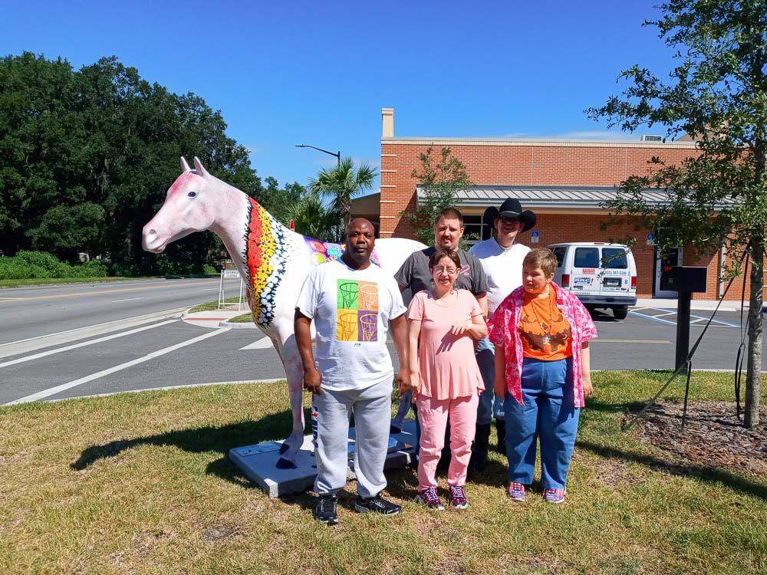
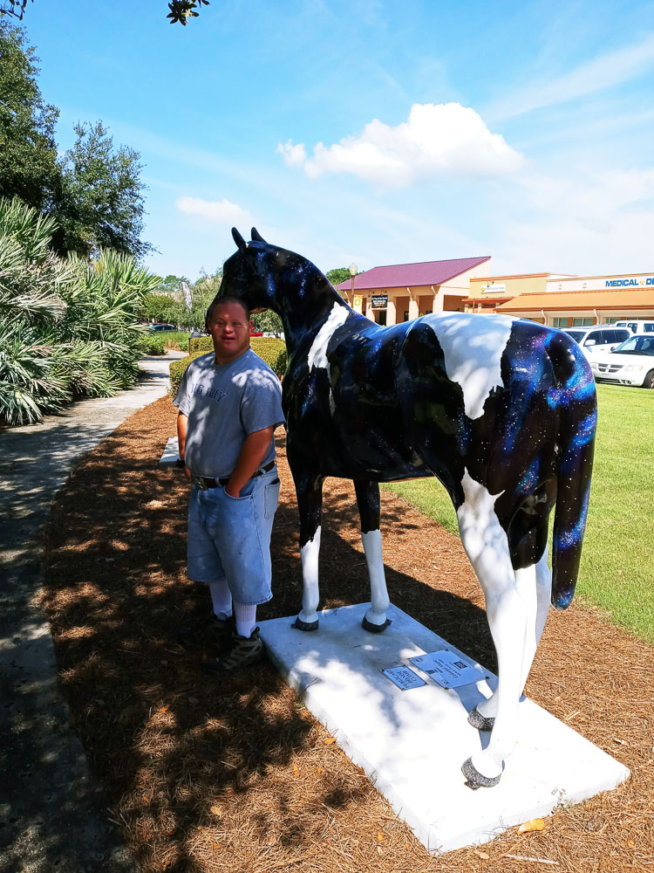
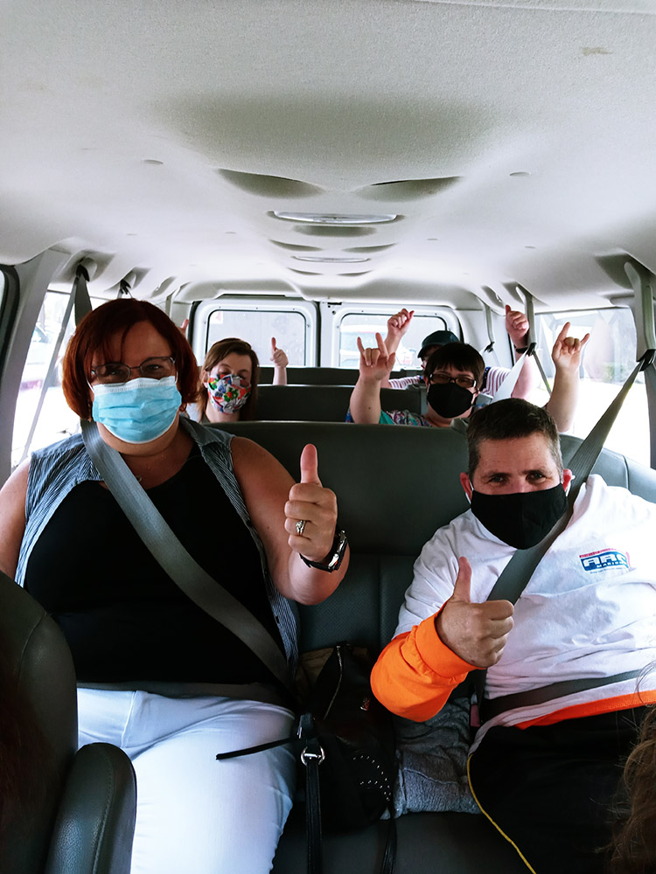
COME WORK HERE! Why Arc Marion is THE place to work…  WHAT IS YOUR HOBBY, YOUR PASSION? Here at Arc Marion, Inc. our goal is to be the EMPLOYER OF CHOICE in Marion County. What that means is, when you, or someone you know, is looking for meaningful employment, Arc Marion is the first place to go. As one of Ocala’s oldest non-profits (60+years!), some of our dedicated and compassionate team members have been with us for over 20 years! Through a concentrated effort, we are focused on being the HIGHEST PAYING disability support provider in the area, with benefits that include health and dental insurance, paid time off, tuition reimbursement programs, and more! Provide the enthusiasm, knowledge and skills necessary to organize and supervise activities in the home, classroom, on campus, and in the community. Whether it is in our Adult Day Training Program or our Group Homes, come share your passion: yoga, art, music, theater, sports, knitting, gardening, the list goes on. If you love it, please consider passing on that love and knowledge!  At Arc Marion, we are offering you a career in the non-profit world, where you are valued, fairly compensated, rewarded with smiles, hugs and high-fives DAILY and are able to come to work each day happy, knowing YOU are making a difference. |  | 