ANNUAL ARC MARION
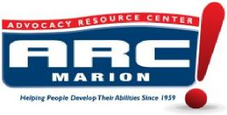 | 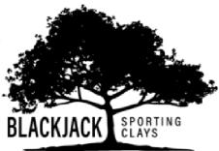 | 3372 COUNTY  RD.526  SUMTERVILLE, FL

FRIDAY– SEPTEMBER 25TH, 2020 @ Black Jack Clays
Sponsor Opportunities:
Presenting Sponsor: $1500 includes banner at registration table, pavilion and logo on score cards. (1) team entry.

Score Card Sponsor: $500

Station Sponsor: $300 (only 16 available.)

Pavilion Sponsor: $200 (banner hung in pavilion where lunch and trophies are given.) Banner provided by Sponsor
COMPANY NAME:
Sponsor Package Selected: __________Phone:__________________
Email:
Payment: (Please make checks payable to ARC Marion) Check # ___
CC: Card #____________________________ Exp:________ CVV:_______
Name on Card:_________________________ Zip:_________

