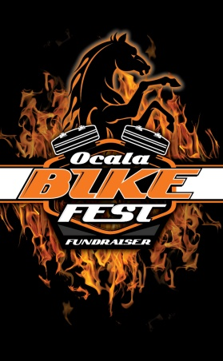 2020 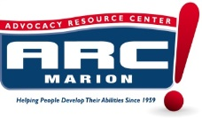
ALL NEW LOCATION: War Horse Harley Davidson
5331 N. Hwy 441 Ocala, Fl 34475
7th ANNUAL OCALA BIKE FEST APRIL 17th & 18th
For more information contact: Cheri Craig 352-351-9048
Sponsorship Opportunities:

$5,000.00 sponsor – Your banner on fence line, banners in tent during event, logo on ARC website/facebook as presenting sponsor, logo in all media adds and flyers. A 20x20 space will be provided for your business promos. (sponsor provides banner, tent, table, supplies.) Your logo on all flyers.

$3,000.00 sponsor – Your banner on fence line, banners in tent during event, name on ARC website/facebook. A 10x20 space will be provided for your business promos. (sponsor provides banner, tent, table, supplies.) Your logo will be on all flyers..

$1,000.00 sponsor – Your banner on fence line, banners in tent during event, name on ARC website/facebook. A 10x10 space will be provided for your business promos. (sponsor provides banner,tent, table, supplies.)

$300.00 sponsor – A 10x10 space, your banner on fence line (sponsor provides banner.)

$200.00 sponsor- your banner on fence. (sponsor provides banner.)

We will have vendors, bands, music, games, custom bike and car show, food, drinks, prizes and much more!

Your banner has the potential to be viewed by the over 65,000 cars a day that drive by ARC Marion!
Thank you for sponsoring ARC we REALLY appreciate your support.

ARC Marion creates opportunities for persons with intellectual and developmental disabilities to live, work and play to the fullest of their capabilities in Marion County. ARC Marion, Inc. is a 501c3 non-profit organization. Registration # CH12985
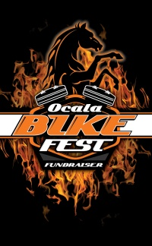2020
ALL NEW LOCATION: WAR HORSE HARLEY DAVIDSON
5331 n. Hwy 441 Ocala, Fl. 34475
For more information contact: Cheri Craig 352-351-9048

7th ANNUAL OCALA BIKE FEST April 17th & 18th
SPONSORSHIP PLEDGE

Company Name:__________________________ Contact Name:___________________________
Address:_________________________________ City:______________St._____Zip____________
Phone#: _______________Cell:_______________ Email:__________________________________
Amount Pledged$__________cash___CK#_______CC#_____________________________exp_____
Signature:_______________________________ Print Name:________________________________

Sponsorship Opportunities:

$5,000.00 sponsor – Your banner on fence line, banners in tent during event, logo on ARC website/facebook as presenting sponsor, logo in all media including print and flyers. A 20x20 space will be provided for your business promos. (sponsor provides banner,tent, table, supplies.) Your logo will be on all flyers.

$3,000.00 sponsor – Your banner on fence line, banners in tent during event, name on ARC website/facebook. A 10x20 space will be provided for your business promos. (sponsor provides banner, tent, table, supplies.) Your logo will on all flyers.

$1,000.00 sponsor –Your banner on fence line, banners in tent during event, name on ARC website/facebook. A 10x10 space will be provided for your business promos. (sponsor provides banner, tent, table, supplies.)

$300.00 sponsor – Your banner on fence line,10x10 space, (sponsor provides banner, tent, table, supplies.)

$200.00 – banner in fence. (sponsor provided banner.)

We will have vendors, bands, music, games, custom bike & car show, food & drinks, prizes and much more!

Your banner has the potential to be viewed by the over 65,000 cars a day that drive by Arc Marion!
ARC Marion creates opportunities for persons with intellectual and developmental disabilities to live, work and play to the fullest of their capabilities in Marion County. ARC Marion, Inc. is a 501c3 non-profit organization. Registration # CH12985

