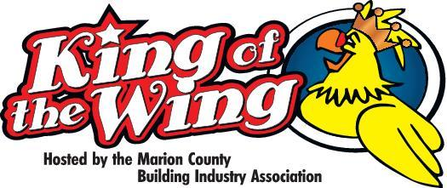
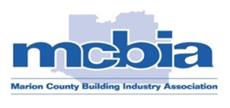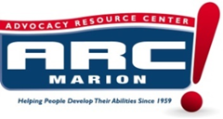
Dear 2020 King of the Wing Restaurant / Amateur Participant,
It’s that time again and we are again moving full speed ahead planning our 2020 King of the Wing. Don’t miss out on this great opportunity to showcase your business to over 1,000+ people by being a competitor at our annual event. The 2020 King of the Wing will be held on Tuesday, March 3rd, 2020 from 5:00 PM to 8:00 PM. We are excited about planning our next event and with ARC Marion teaming with us as our charitable partner, we will again assure for another successful community event and help the clients of ARC Marion! This event will be held at The Southeastern Livestock Pavilion located at 2232 NE Jacksonville Road, Ocala, FL. Advertising of this event will be massive, and we are expecting another record turnout for this event.
The cost for tickets in advance is $30 for adults and includes 4 drinks, $15 for children ages 5-12 and includes 2 drink, for a sampling of wings from each participant and 2 beverages of your choice! There will be great music, beverages, free give-a-ways and much, much more! Bring your appetite and bring your family, friends and neighbors too!
As a participating restaurant contestant, you and your business will also receive recognition on the MCBIA and ARC website!!!
If you have any questions or need additional information about being a restaurant/amateur contestant, please contact us at the phone numbers shown below.
Sincerely,
Your 2020 King of the Wing Committee Co-Chairs:
Cheri Craig ARC Marion: 352-351-9048 ccraig@mcarc.com Christine Ellis, The Marion County Building Industry Association: 352-694-4133 opt 1 christine@mcbia.org
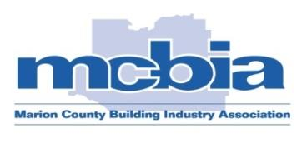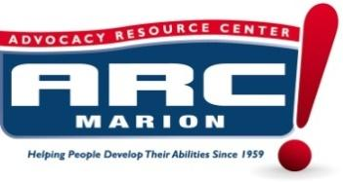
2020 King of the Wing Contestant Participation Agreement
On behalf of__________________________________________ (Restaurant/Individual Name) we agree to participate in the MCBIA’s 14th Annual King of the Wing competition on Tuesday, March 3rd, 2020 from 5 to 8 PM at The Southeastern Livestock Pavilion, 2232 NE Jacksonville Road, Ocala, FL.
I hereby agree to bring 800 - 1,000 chicken wings (1 or more of our best recipes), MCBIA will supply me with 2 banquet style tables, all other items will need to be provided by me, i.e., fire extinguishers, linen, serving utensils, pop-up tent, chairs, condiments (ranch, blue cheese, celery) etc. NO other food items will be allowed to be served other than wings, celery/carrots, blue cheese or ranch dressing or specialty dressing of your choice. I will be at the event location between 1pm and 2pm, set-up and ready to serve at 5 PM on the day of the event. My restaurant will be given (2) tickets to enjoy the event and I may bring as many staff members as needed to set-up but will be limited to 6 staff members once the gates open. ALL other staff (other than the 2 tickets given will be required to purchase a $30 ticket to remain in attendance. You will be able to prepare your wings on site in an outside pre-designated area, so they are as fresh as possible. Site prepared cooking must meet Fire Code requirements (you bring the proper fire extinguisher) on site, please be aware if using a smoker & deep fryer you must provide 2 different types of extinguishers! Grease tubs will be provided on site for disposal of your used grease. No shows will be charged a fee of $350.
Signed:______________________________________________________ Date:________________________________
Print Name:_________________________________________________ Email:________________________________
Phone:______________________________ FAX:_________________________ Cell:___________________________
Amount of space required: X (Average size 10x20)
RESTAURANT JUDGING CATAGORIES & OTHER PARTICIPANT PLAQUES
“King of the Wing” (restaurants only) -Judged by: A Sequester Panel of Judges! Only One will be crowned the winner!!!
“People’s Choice” – Judged by: Attendees
King of the Wing-Judge Panel-1ST Place trophy, 2nd & 3rd place plaques
People’s Choice–(voting booth)-1st Place trophy, 2nd & 3rd place plaques
King the Wing- (2nd place-plaque and 3rd place-plaque)
Wing Master- (trophy)

BEST AMATURE WING – “Wing Master” (Trophy) – Only non-restaurant participants can enter in this category. Winning group will receive a trophy and recognition on stage to receive the award.

Judge Panel- 1st place trophy, 2nd and 3rd place plaques
People’s Choice- (voting booth)- 1st Place Trophy, 2nd and 3rd Place Plaques

