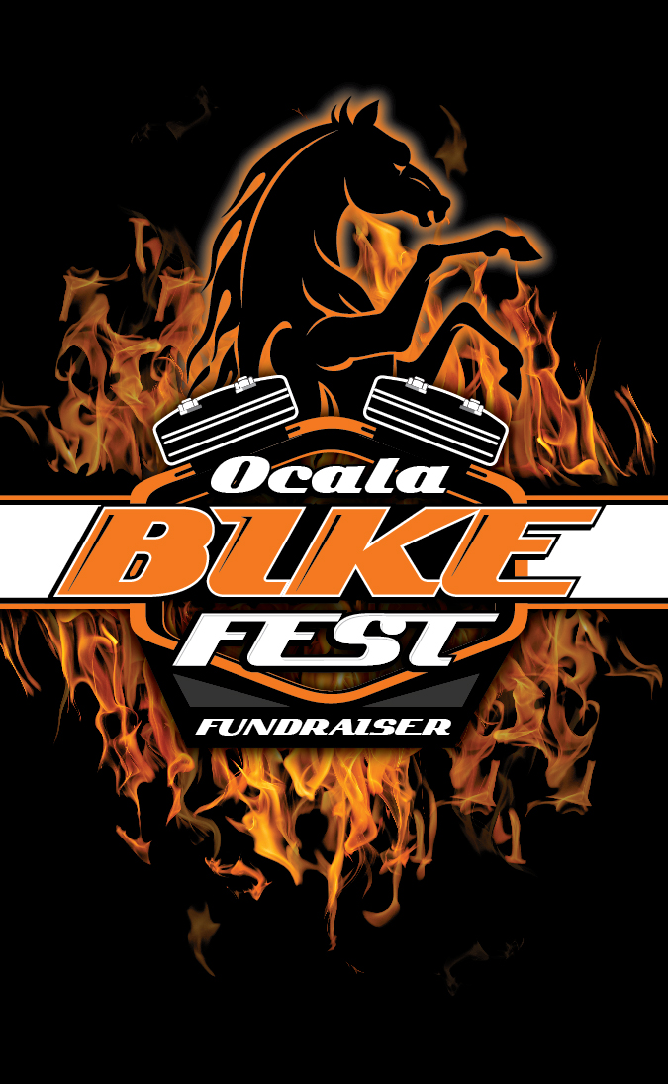
VENDOR APPLICATION April 12th, 13th & 14th 2019
ALL NEW PRIME LOCATION: War Horse Harley Davidson
5331 N. Hwy 441 Ocala, Fl. 34475

NAME OF COMPANY: ________________________________________
ADDRESS:__________________________________________________
EMAIL: ____________________________________________________
CONTACT PERSON: __________________________________________
PHONE #: __________________________________________________
SPACE SIZE NEEDED: _________________________________________
PRICE $: ___________________________________________________
CREDIT CARD #:____________________EXP. DATE:________________
ABSOLUTLY NO HARLEY DAVIDSON ITEMS SOLD BY VENDORS!!!
ALL vendors must be set up by 2:00pm on 4/12, NO early break down!
NO campers or camping on site!
PRICE AS FOLLOWS: ALL 10X10 SPACES $200 EACH. If you donate an item valued at $25 or more for our raffle then take $25 off your vendor fee!
Limited space & NO electric available! Entry Deadline April 8th!
MAKE CHECKS PAYABLE TO: ARC MARION, INC.
MAIL TO: ARC MARION, INC.
2800 SE MARICAMP RD.
OCALA, FL 34471
Contact information: 352-387-2210/ccraig@mcarc.com

